Ready to register your yard sale? Complete this form either:
E-mail it to winonawoodsna@gmail.com
Mail it to Winona Woods Neighborhood Association, 35 Chelsea Rd, Rochester NY, 14617
Turn it in at a monthly meeting
Turn it in to your Street Captain
Name | Click here to enter text. | Days  Open | ☐Friday 6/13  ☐Saturday 6/14
Address | Click here to enter text. | VOA Pick Up  (see below) | ☐Yes  ☐No
Sale Description | Click here to enter text.
In order to cover marketing costs there is a suggested donation of $5.00 to register your yard sale. In return your sale will be included in the Garage Sale Map, you will receive balloons for your sale to identity it as an official WWNA Yard Sale and a Volunteer’s of America Truck can be requested to pick up any leftover items that did not sell if requested.
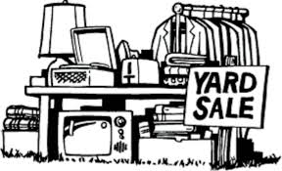
Have stuff to get rid of but aren’t able to have a yard sale or are uninterested in doing so?
Not a problem. Donate your items to the WWNA and we will sell them at a joint sale.
Any sale profits will be kept to help fund the neighborhood association.

